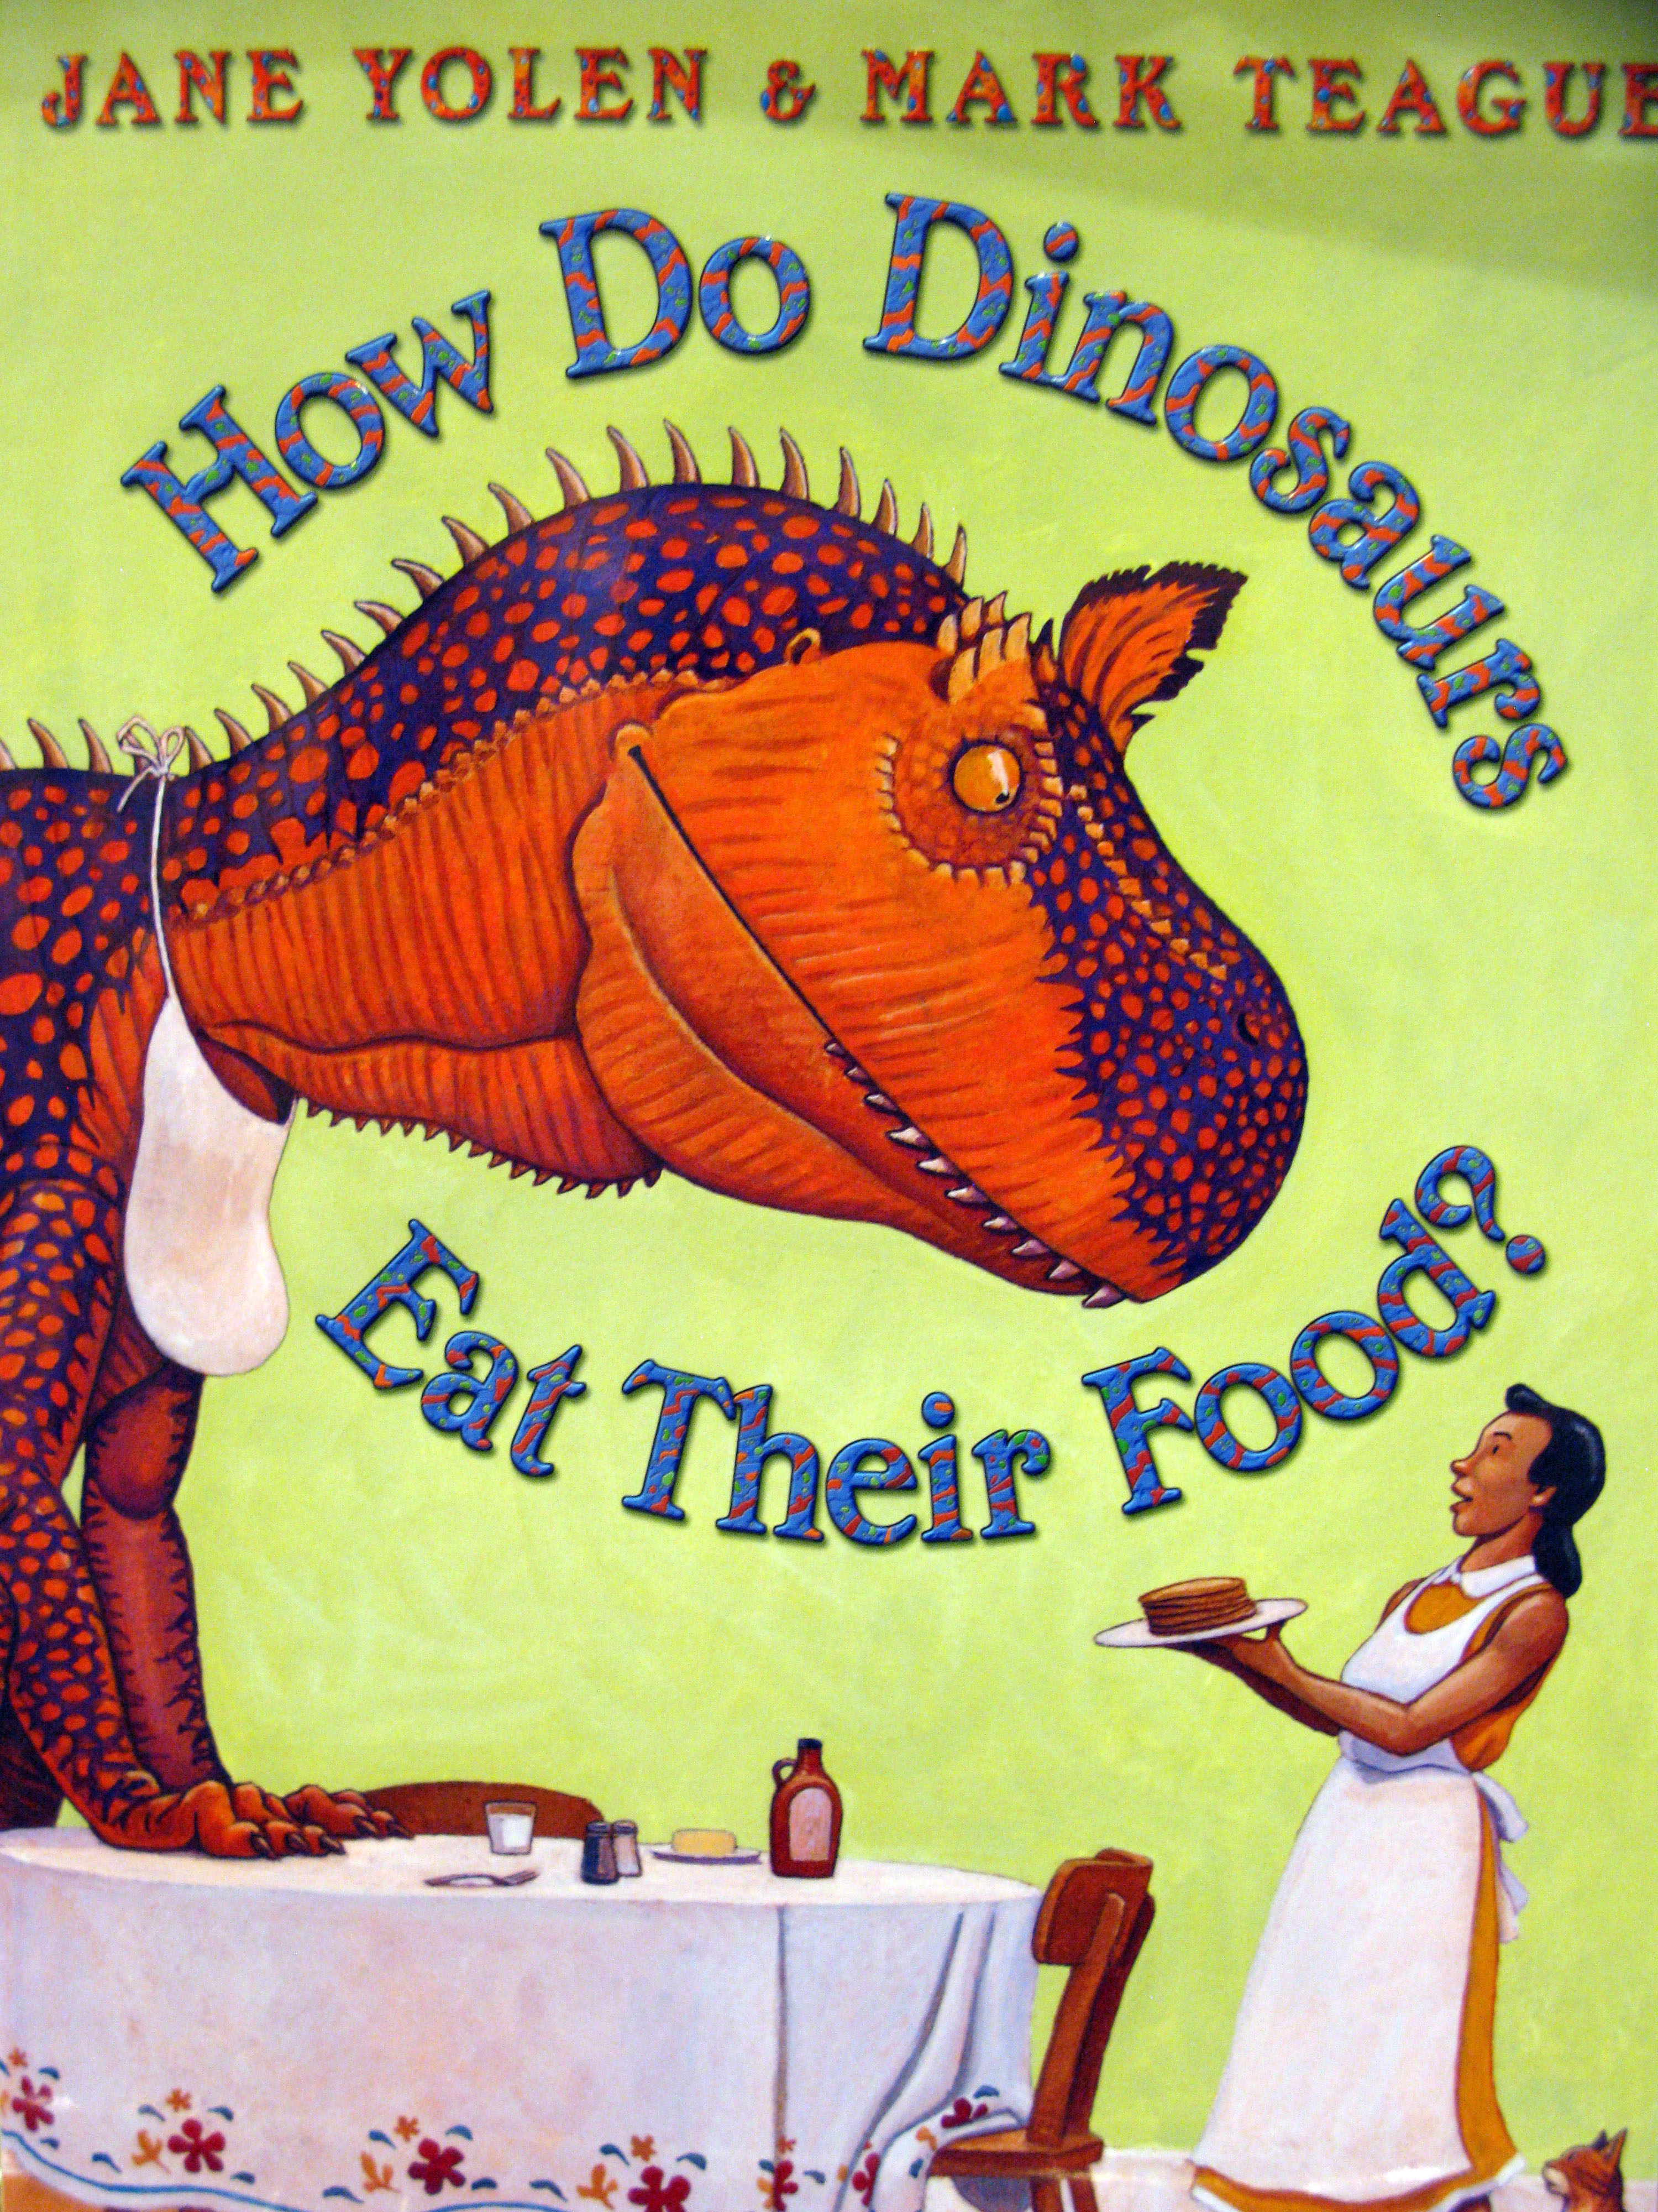
Small Group Read Aloud Program: Integrative Strategy Guide
Title: How Do Dinosaurs Eat Their Food?
Author: Jane Yolen
Illustrator: Mark Teague
Age Range: 4-7
Topics/Themes: Rhyming, Etiquette, Dinosaurs, comparing and contrasting behavior
Vocab: fidget, glare, partially, goodwill
See video of this book read aloud here: How Do Dinosaurs Eat Their Food?
- Components of Book (review each session)
- Author, Illustrator
- Title, Front and Back cover

- Introduction-- before reading:
- After looking at the cover illustration, can you guess what the story is about? What makes you think that?
- What do you know about dinosaurs? Do they eat at a dinner table?

- Integrative Strategies

During reading strategies:
p.5 What does the word "fidget" mean? Why do you think the dinosaurs fidget?
p.10. Show me how you would " glare". How are you feeling when you glare at someone?
p. 18. What do you predict is going to happen next? Why do you think that?

Post reading strategies

- Conduct a picture walk having students retell the story.
- How do the parents feel in each picture? What makes you think that?
- Point out to students that the name of each dinosaur is hidden on each page.
- Why do you think the author wrote this story? What was her message?
- Is this story fiction (make-believe) or non-fiction (true information and facts) What in the story makes your think that?
- What are some good manners that you use when you eat? Do you think it's important to use good manners? Why or why not? Do you use different manners in different settings?

- Supplemental activity:
Show the students the back page of the book that names many different types of dinosaurs. Look at the pictures and read the names. What are some ways these dinosaurs are alike? What are some ways they are different?

