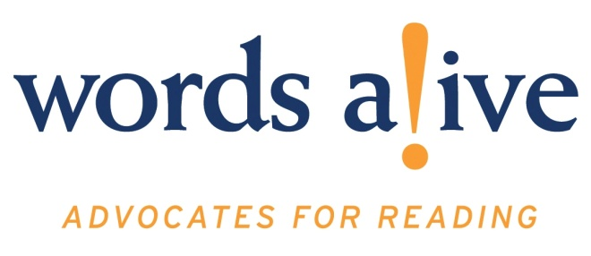
University of Southern California

The San Diego Academic Center offers a fully accredited Master of Social Work program for full-time and part-time students. The center, located 20 miles north of San Diego in Rancho Bernardo, offers foundation and concentration courses for the MSW degree, along with the option of a military social work specialization. The San Diego Academic Center enjoys a close working relationship with Camp Pendleton, the major West Coast base of the U.S. Marine Corps, as well as the VA Medical Center and other government, health and social services agencies in the area. The USC School of Social Work has long recognized the growing need to train social workers in mental health services for veterans and their families, and the academic center’s proximity to such a large military population offers students an ideal place to study military social work.

Campus Resources:
List of Majors and their websites
Academic Calendar 2016-2017

Location
16870 West Bernardo Drive, Suite 200
San Diego, CA 92127

Contacts

Michael Rank
Director, USC San Diego Academic Center
858.675.0167
rank@usc.edu

Meryl Livingston
Office Manager
858.675.0167 ext 201
mjliving@usc.edu

Jen Parga
Recruitment Coordinator
619.726.4235
jparga@usc.edu

Laurie Lovell
Administrative Assistant
858.675.0167 ext 214
llovell@usc.edu

Financial Aid
The University of Southern California Financial Aid Office will provide you with the details of applying for financial aid, understanding your financial aid award and properly securing all of your loans. Please visit the USC Financial Aid Office (FAO) website for detailed information regarding dates and deadlines, as well as downloadable forms to complete your financial aid application.
- Resources for Financial Aid
- Federal Loans
- Additional Resource

In addition to loan programs administered by the USC Financial Aid Office, we also encourage you to explore the following scholarship and loan forgiveness resources.

School of Social Work Scholarships
The USC School of Social Work offers supplemental financial assistance to students whose financial need cannot be adequately met through need-based loans. To apply for any of these school scholarships, please complete the Virtual Academic Center Scholarship Application at the time you apply for admission.
Virtual Academic Center Dean’s Leadership Scholarship
Scholarship awards for incoming full-time Virtual Academic Center students with demonstrated leadership capacity and experience. All interested and eligible students must have a minimum 3.0 GPA, with two or more years of human/social service and leadership experience. Students will be considered based on the aforementioned criteria, leadership skills, experience and interests detailed in the resume and statement of purpose, as well as the overall quality of the admissions application.
Virtual Academic Center Scholarship
Scholarships awarded to students enrolled in eight or more units with a minimum 3.0 GPA. Award amounts vary based upon need and academic merit.
Yellow Ribbon Scholarship
Students eligible for the Post-911 G.I. Bill who meet the specified criteria can earn tuition awards of up to $20,000 through a matched scholarship program with the U.S. Department of Veterans Affairs.
City Year Scholarship
The City Year Scholarship is awarded to two incoming students each academic year, who have performed a year of service to underprivileged communities and demonstrate academic merit. Recipients are awarded $15,000 per academic year (one installment each semester) over two years for a total of $30,000. The award will automatically renew for the second academic year as long as students remain in good academic standing and enrolled in the two-year full-time program. For more information, please visit the City Year website.

University Scholarships and Fellowships
Many USC-affiliated organizations offer competitive scholarships to qualifying students who demonstrate merit, financial need and campus and community involvement.
- Norman Topping Student Aid Fund
- USC Asian Pacific Alumni Association Scholarship
- USC Black Alumni Association Scholarship
- USC Lambda LGBT Alumni Association Scholarship
- USC Latino Alumni Association Scholarship
- Rockwell Dennis Hunt Scholastic Award
- Town and Gown Scholarships
- University Staff Club Graduate Scholarships

Professional Organization and Foundation Resources
This is a partial listing of scholarship funds available to social work and graduate-level students, some of which promote community building, social justice and other social work-related ideas.
- American Association of University Women
- Council on Social Work Education
- Davis-Putter Scholarship Fund
- Hispanic Scholarship Fund
- Jeannette Rankin Women’s Scholarship Fund
- National Association of Social Workers Foundation
- Point Foundation
Additionally, you should consult other financial aid sources through local libraries, online search engines, federal agencies, private foundations and organizations.
Student Resources http://sowkweb.usc.edu/student-resources
Based on where you are in your journey at the USC School of Social Work, choose from the following options to find the tools you'll need to succeed as a member of the Trojan Family.

Deadlines http://sowkweb.usc.edu/admissions/master-of-social-work/deadlines
Traditional MSW students begin the campus-based program in the fall semester; we do not offer spring or summer matriculation. The campus-based MSW program has two application deadlines for the 2014-2015 academic year. If you are applying for admission to the Virtual Academic Center, please refer to its individual schedule of application deadlines and start dates. Campus-based advanced standing students start in the summer with their bridge courses.

