Small Group Read Aloud Program: Integrative Strategy Guide
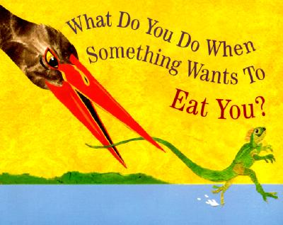
Title: What Do You Do When Something Wants to Eat You?
Author: Steve Jenkins
Age Range: 7-10
Topics/Themes: Predators
Vocabulary: pangolin, armor-plated, immune
See video of this book read aloud here: What Do you Do When Somthing Wants to Eat You

- Introduction (Prep Questions)
- What do you think this story will be about?
- What do you think the bird is trying to do?
- How could the lizard protect itself?

- Integrative Strategies

  - Post Reading Session
- Review book with students, by conducting a picture walk.

- There is two pages in the book that match the title page, have students help you to find those pages.

- What was the main topic of this story?

- What type of defenses do animals use to keep themselves from being harmed?

- How does camouflage work? Which animal is the story used camouflage to protect itself?

- What causes animals to need to defend themselves?

- What are the effects of them being attacked? What if there were no predators?

- What creature do you think had the best method of defense from its attacker?

- Use last page to talk to students about what they would do if something wanted to eat them.

- What was your favorite animal in the story that had the most interesting way to protect itself?

