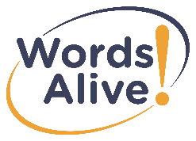
Words Alive Stock Transfer Verification Form
Thank you for thinking of Words Alive as a beneficiary to your donation of stock.

Words Alive Account Information
Account registration/client name: Words Alive
Schwab A/C#: 7990-6289
Delivery Instructions:
All DTC-Eligible Securities
All deliveries MUST include client name and Schwab account number.
Delivery to DTC Clearing 0164, Code 40

For Donor to Complete:
Donor Name:_______________________________________________________________________
Donor Address:_____________________________________________________________________
Donor Phone/Email:__________________________________________________________________

Donation of ________ shares of _______________________________________________stock.

For Stock Transfer Agent:
Total number of shares transferred: _________
Total Dollar Value of Transfer: $____________
Date Transfer Completed: ________________

Please return completed form to:
Words Alive
c/o Rachael Orose
770 Park Blvd
San Diego, CA 92101
Phone: (858) 274-9673
Email: info@wordsalive.org

